MODUL 6

E-mail Services and Protocols

TUJUAN:
- Memahami Komponen Utama Mail Server
- Memahami Capture and analyze e-mail communication between the pod host computer and a mail server

DASAR TEORI

E-mail is one of the most popular network services that uses a client/server model. The e-mail client is configured on a user’s computer, and configured to connect to an e-mail server. Most Internet service providers (ISPs) provide step-by-step instructions for using e-mail services; consequently, the typical user may be unaware of the complexities of e-mail or the protocols used.

In network environments where the MUA client must connect to an e-mail server on another network to send and receive e-mail, the following two protocols are used:

Simple Mail Transfer Protocol (SMTP) was originally defined in RFC 821, August, 1982, and has undergone many modifications and enhancements. RFC 2821, April, 2001, consolidates and updates previous e-mail -related RFCs. The SMTP server listens on well-known TCP port 25. SMTP is used to send e-mail messages from the external e-mail client to the e-mail server, deliver e-mail to local accounts, and relay e-mail between SMTP servers.

Post Office Protocol version 3 (POPv3) — is used when an external e-mail client wishes to receive e-mail messages from the e-mail server. The POPv3 server listens on well-known TCP port 110 .

Earlier versions of both protocols should not be used. Also, there are secure versions of both protocols that employ secure socket layers/Transport layer security (SSL/TSL) for communication.

E-mail is subject to multiple computer security vulnerabilities. Spam attacks flood networks with useless, unsolicited e-mail, consuming bandwidth and network resources. E-mail servers have had numerous vulnerabilities, which left the computer open to compromise.

Mail server yang umum digunakan untuk mengelola email berbasis domain (seperti Postfix, Dovecot, hMailServer) mengguna

kan protokol standar SMTP (pengiriman), serta POP3/IMAP (penerimaan/akses). Akses berbasis web (webmail) biasanya didukung aplikasi front-end seperti Roundcube, Horde, atau SquirrelMail atau Zimbra Web Client yang terintegrasi dengan server email tersebut.

Komponen Utama Mail Server

MTA (Mail Transfer Agent) - SMTP: Postfix (umum di Linux), Sendmail, Qmail.

MDA (Mail Delivery Agent) - POP3/IMAP: Dovecot, Courier, hMailServer (Windows).

Webmail Client: Roundcube, SquirrelMail (antarmuka web).

Web Server Pendukung: Apache, Nginx (untuk menjalankan webmail).

Protokol Email Utama

SMTP (Simple Mail Transfer Protocol): Protokol utama untuk mengirim dan meneruskan email antar server.

POP3 (Post Office Protocol 3): Mengunduh email dari server ke perangkat, biasanya menghapus salinan di server.

IMAP (Internet Message Access Protocol): Menyinkronkan email antara server dan perangkat, memungkinkan akses dari beberapa perangkat.

Proses instalasi mail server sendiri biasanya tergolong kompleks, memerlukan konfigurasi DNS (MX Record, A Record) agar domain email berfungsi dengan baik.

Lab

- Topology Diagram
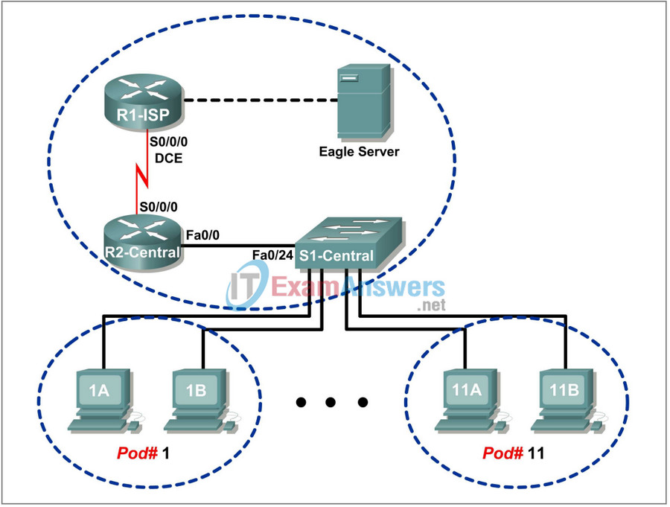
Figure 1: E-mail Services and Protocols

- Addressing Table
Table 1: Addres Table

Device | Interface | IP Address | Subnet Mask | Default Gateway
R1-ISP | S0/0/0 | 10.10.10.6 | 255.255.255.252 | N/A
 | Fa0/0 | 192.168.254.253 | 255.255.255.0 | N/A
R2-Central | S0/0/0 | 10.10.10.5 | 255.255.255.252 | N/A
 | Fa0/0 | 172.16.255.254 | 255.255.255.0 | N/A
Eagle Server | N/A | 192.168.254.254 | 255.255.255.0 | 192.168.254.253
 | N/A | 172.31.24.254 | 255.255.255.0 | N/A
hostPod#A | N/A | 172.16. Pod#.1 | 255.255.0.0 | 172.16.255.254
hostPod#B | N/A | 172.16. Pod#.2 | 255.255.0.0 | 172.16.255.254
S1-Central | N/A | 172.16.254.1 | 255.255.0.0 | 172.16.255.254

- Learning Objectives
- Background
- Scenario

Task 1: Configure the Pod Host Computer for E-mail Service.

Task 2: Capture and Analyze E-mail Communication between the Pod Host Computer and an E-mail Server.
Task 3: Challenge
Task 4: Reflection
Task 5: Clean Up

Figure 2

Referensi:
https://itexamanswers.net/lab-3-4-3-e-mail-services-and-protocols-answers.html
https://www.hypernet.co.id/id/cara-kerja-mail-server-penjelasan-lengkap-untuk-anda/
https://www.wowrack.com/id-id/blog/managed-services-id/server-mail-fungsi-cara-kerja-mail-server/
https://itexamanswers.net/lab-3-4-3-e-mail-services-and-protocols-answers.html

https://itexamanswers.net/lab-3-4-3-e-mail-services-and-protocols-answers.html#google_vignette

HW:

10.2.1.7 Packet Tracer – Web and Email

https://itexamanswers.net/10-2-1-7-packet-tracer-web-and-email-answers.html

Contents

10.2.1.7 Packet Tracer – Web and Email Answers
Topology
Objectives
Background

Part 1: Configure and Verify Web Services
Step 1: Configure web services on CentralServer and BranchServer.
Step 2: Verify the web servers by accessing the web pages.

Part 2: Configure and Verify Email Services on Servers
Step 1: Configure CentralServer to send (SMTP) and receive (POP3) Email.
Step 2: Configure BranchServer to send (SMTP) and receive (POP3) Email.
Step 3: Configure PC3 to use the CentralServer email service.
Step 4: Configure Sales to use the Email service of BranchServer.
Step 5: Send an Email from the Sales client and the PC3 client.
Download Packet Tracer (.pka) file:
10.2.1.7 Packet Tracer - Web and Email.pka Completed 1.15 MB 15856 downloads

